**Week 1-Design Pattern and Principles**

**Ex 1: SingleTonPattern**

**Logger.java**

public class Logger {

private static Logger instance;

private Logger() {

System.out.println("Logger initialized.");

}

public static Logger getInstance() {

if (instance == null) {

instance = new Logger();

}

return instance;

}

public void log(String message) {

System.out.println("Log: " + message);

}

}

**SingletonTest.java**

public class SingletonTest {

public static void main(String[] args) {

Logger logger1 = Logger.getInstance();

logger1.log("First log message.");

Logger logger2 = Logger.getInstance();

logger2.log("Second log message.");

System.out.println("Same instance? " + (logger1 == logger2));

}

}

**Output:** 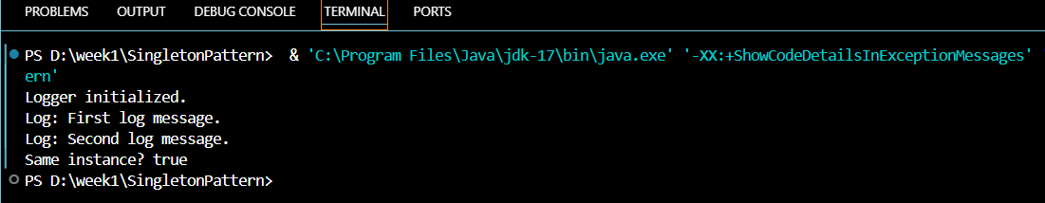

**Ex 2: Factory Method Pattern – Document**

public class FactoryMethodPatternExample {

public static void main(String[] args) {

DocumentFactory wordFactory = new WordFactory();

Document word = wordFactory.createDocument();

word.open();

DocumentFactory pdfFactory = new PdfFactory();

Document pdf = pdfFactory.createDocument();

pdf.open();

DocumentFactory excelFactory = new ExcelFactory();

Document excel = excelFactory.createDocument();

excel.open();

}

}

interface Document {

void open();

}

class WordDocument implements Document {

public void open() {

System.out.println("Opening Word Document.");

}

}

class PdfDocument implements Document {

public void open() {

System.out.println("Opening PDF Document.");

}

}

class ExcelDocument implements Document {

public void open() {

System.out.println("Opening Excel Document.");

}

}

abstract class DocumentFactory {

public abstract Document createDocument();

}

class WordFactory extends DocumentFactory {

public Document createDocument() {

return new WordDocument();

}

}

class PdfFactory extends DocumentFactory {

public Document createDocument() {

return new PdfDocument();

}

}

class ExcelFactory extends DocumentFactory {

public Document createDocument() {

return new ExcelDocument();

}

}

**Output:** 